- Load the Iris dataset using scikit-learn and use cross_val_score() with a KNeighborsClassifier to compute the average accuracy using 5-fold cross-validation.

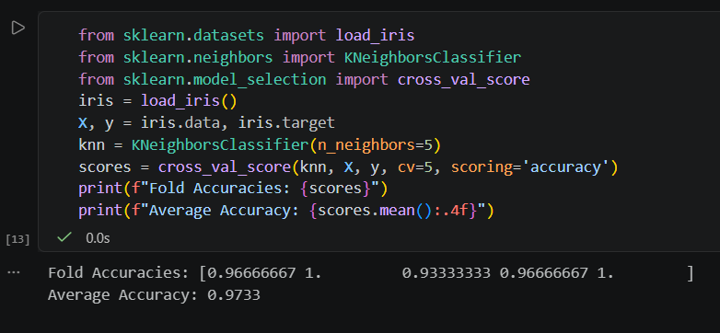

- For a dataset of your choice (e.g., Titanic or any from scikit-learn), perform 10-fold cross-validation using cross_val_score() with a DecisionTreeClassifier and print the accuracy for each fold.

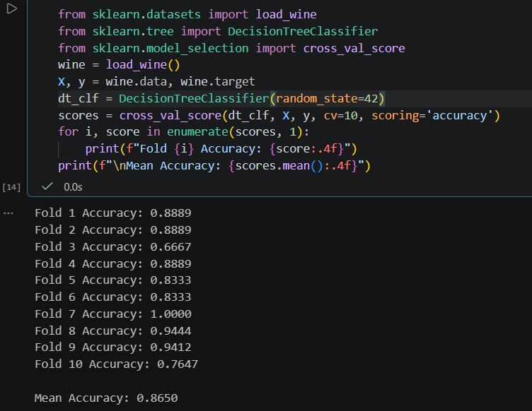

- Use StratifiedKFold from scikit-learn to split the Iris dataset and compare the distribution of target classes in each fold to show how stratified sampling works.Print the class counts for each fold to verify stratification.

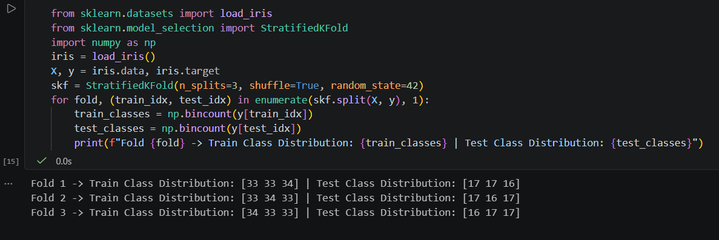

- Experiment with different values of 'cv' (3, 5, 10) in cross_val_score() for a RandomForestClassifier on the Wine dataset and report which value gives the most stable (least variable) accuracy scores. Look at the standard deviation of the scores for each cv value.
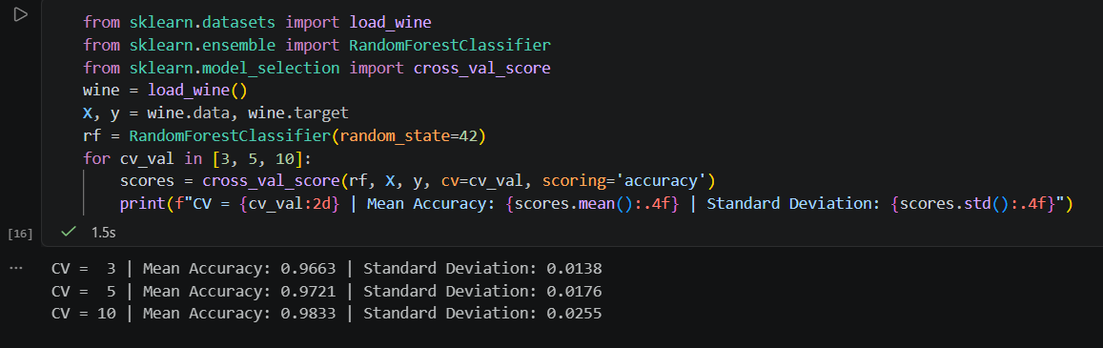

Observation: Typically, $cv=10$ provides a more stable, reliable evaluation with lower variance (standard deviation) across folds because the training subsets are larger ($90\%$ of the data per fold), allowing the model to train on more diverse patterns consistently.

- Use ChatGPT or Copilot to help you write a function that takes any classifier and dataset, runs k-fold cross-validation using cross_val_score(), and returns the mean and standard deviation of the scores. Paste the code you generated and briefly describe how the AI tool improved your solution.

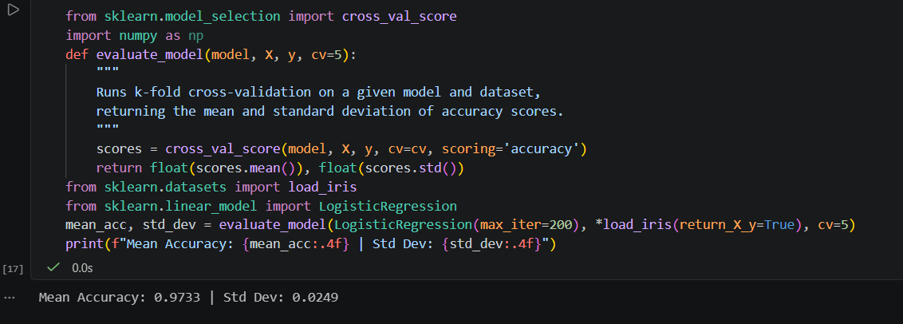

How the AI tool improved the solution: The AI optimized the implementation by designing a clean, modular helper function with a built-in docstring, automatic score aggregation using numpy, and unpacking syntax (*load_iris(return_X_y=True)) for rapid testing across different classifiers.

